 | 9.1.1 Editors - UV Editor - Header - Header Tools and Options
Table of content
UV Editor - Header Tools 2
Pivot 2
Snapping 2
Snapping Settings 2
Absolute Grid Snapping 2
Affect 3
Proportional Editing 3
Settings 3
Proportional Size 3
UV Map Property 3
Image Prop 4
List of images in the scene 4
Search form 4
Image Edit Box 4
Number of Fake Users 4
Fake User 4
Open 4
Remove 4
New Image 4
Name 4
Width 5
Height 5
Color 5
Alpha 5
Generated Type 5
32 Bit Float 5
Duplicate 5
Unlink Datablock 5
Fake User 5
Open Image 5
Unpack 6
User 6
Use Image Pin 6
Show Overlays 6
Guides 6
Grid 6
Dynamic / Fixed / Pixel 6
Grid over Image 6
Tiles 6
Display Stretch 7
Display Stretch Type 7
Area 7
Angle 7
Geometry 7
UV Opacity 7
Display as 7
Modified Edges 7
Faces 7
Image 8
Show Metadata 8
Display Channels 8
Color and Alpha 8
Color 8
Alpha 8
Red 8
Green 8
Blue 8
Options Panel 8
Constrain to Image Bounds 8
Live Unwrap 8
Update Automatically 9
UV local view 9
Show Metadata 9
Snap to Pixels 9

UV Editor - Header Tools

The header contains several tools, dependent of what you do and what tool set is selected.

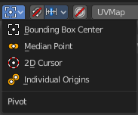
Pivot
What pivot point to use for selected elements.
When you rotate or scale an UV patch, or a group of vertices/edges/faces, you may want to set the pivot point to a specific location of the selection. The names should be self explaining.

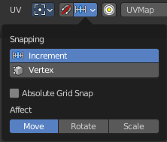
Snapping
Activate snapping when transforming an element.
Snapping can be temporarily activated by holding CTRL key. So no need to turn snapping on and off all the time.

Snapping Settings
You can snap to various scene elements. This menu allows you to define to which other elements the current active element should snap to. The names should be self explaining. Increment snaps by a grid unit.

Absolute Grid Snapping
Absolute grid alignment while translation, based on the pivot center.

Affect
Adjust what transform methods should be affected by snapping.

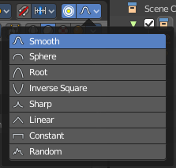
Proportional Editing
Enables proportional editing.
Proportional Editing is a way of transforming selected elements (such as vertices) while having that transformation affect other nearby elements with a falloff. For example, moving a single vertex will move unselected vertices within a given range. And the falloff means that selected vertices that are closer to the selected vertex will move more than those farther from it.

Settings
The settings appears when you activate Proportional Editing. Choose between different falloff methods for the proportional editing. The settings hides when proportional editing is off.

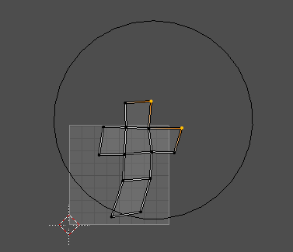
Proportional Size

When proportional editing is on then you will see a black circle around the selection that defines the influence area of the proportional editing.
This value can be adjusted with the scroll wheel, the page up and page down hotkeys, and in the last operator panel of the transform tools.

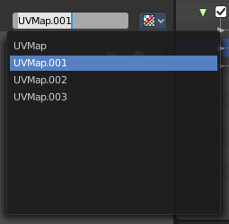
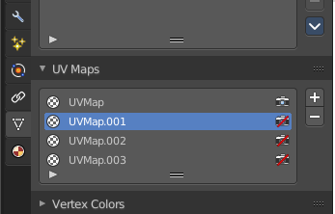
UV Map Property
A mesh can have more than one UV map. You create them in the Properties editor in the Object Data Properties tab in the UV Map Panel.

The property in the header allows you to switch to another UV map, and to rename the UV map.

Image Prop
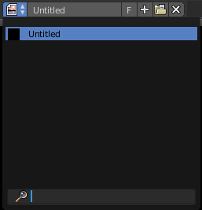
This property contains the list of loaded images. When no image is loaded then it displays the New and Open Buttons. When an image exists then it displays the name of the currently selected image.

From left to right ...

List of images in the scene
This is a list of the images in the scene. This list allows you to switch to other images.

Search form
Search for specific images.

Image Edit Box
Read the name of the currently selected image. And you can rename the image here too.

Number of Fake Users
In case this file has a fake user assigned, then this number displays the number of fake users.

Fake User
Wit this button you assign a fake user to this selected image.
Data, like images, that is not longer linked to anything else gets removed when you save and reload a scene. Bforartists has the concept of fake users to go around this behavior. An image with a fake user is in fact linked to something. And so it is not lost when you save and reload the scene.

Open
Open a new image.

Remove
Removes the image.

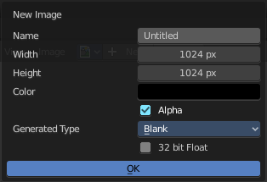
New Image
Create a new image.
Creates a new image. You will get a dialog where you can define settings for the new image.

Name
The name of the new image

Width
The width of the new image.

Height
The height of the new image.

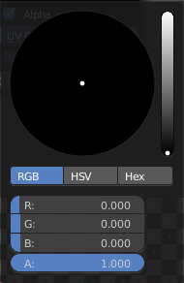
Color
Adjust the color of the new image. A click will call a color picker.

Alpha
Check this checkbox if the new image should have an alpha channel.

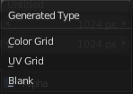
Generated Type
Here you can define what kind of texture you want to create.
Blank is one plain color.
UV Grid is a checker texture in black and white.
Color Grid is a colored checker texture.

32 Bit Float
Check this checkbox if the image should be in 32 Bit floating point bit depth per channel. Else it is in 8 bit per channel.

Duplicate
Not supported here.

Unlink Datablock
This deletes the selected image. Unfortunately not immediately. You need to save the scene and to reload it.
And you need to make sure that it is not linked to anything else. A mesh or a fake user for example. Have a look if there is a number besides the F button. When this is the case then the image has still a user, and so still loads with loading the scene.

Fake User
Wit this button you assign a fake user to this selected image.
Data, like images, that is not longer linked to anything else gets removed when you save and reload a scene. Bforartists has the concept of fake users to go around this behavior. An image with a fake user is in fact linked to something. And so it is not lost when you save and reload the scene.

Open Image
Opens the file browser to load an image.

Unpack
Unpack packed files to a directory.

User
The number of users that uses this data. Data with a user number of 0 will be removed with closing Bforartists.

Use Image Pin
When you select another object. for UV mapping for example, then usually the connected images for this object gets displayed. Use image pin nails the currently selected image so that it stays displayed.

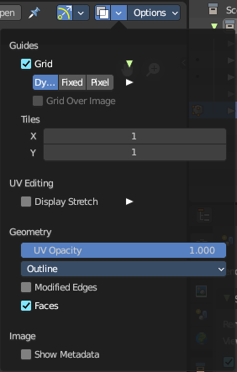
Show Overlays

Guides

Grid
Display the ground grid.

Dynamic / Fixed / Pixel
Display the ground grid in defined resolution.
Dynamic adapts to the image size.
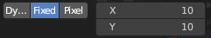
Fixed uses a fixed grid resolution. Fixed reveals x y edit boxes to set up the fixed resolution.
Pixel orients the grid size at the pixel resolution.

Grid over Image
Display the grid over the image.

Tiles
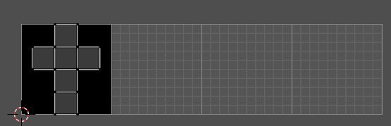
Display more tiles in the viewport than just the one in the 0-1 range. This is needed in conjunction with UDIM tiles.

Display Stretch
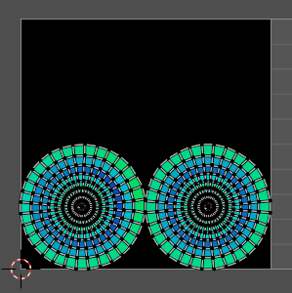
Display the uv mapping with different colors, dependant of the stretchiness of the uv mapped mesh. The different colors shows you how distorted the texture at the mesh is displayed. Blue is no stretching. Red is highly distorted stretching.

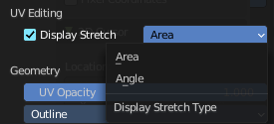
Display Stretch Type

Area
Calculates the stretch between UV and 3D faces.

Angle
Calculates the angular distortion between UV and 3D faces.

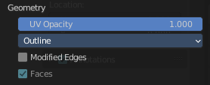
Geometry

UV Opacity
The opacity of the UV wireframe.

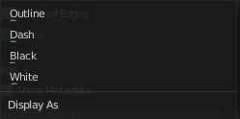
Display as
How to display the UV wireframe.

Modified Edges
Display the edges after the modifiers is applied. Else it shows the edges before the influence of the modifiers.

Faces
Show the faces in the UV Wireframe. Not available with Display Stretch since Display Stretch needs to display the faces to work.

Image

Show Metadata
Display existing metadata in the viewport.

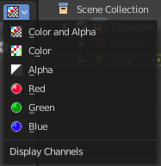
Display Channels
Adjust what channels of the image gets displayed. It just shows when an image is loaded and active.

Color and Alpha
Displays the whole image, including alpha channel.

Color
Displays the whole image, but without alpha channel.

Alpha
Displays the alpha channel of the image.

Red
Displays the red channel of the image.

Green
Displays the green channel of the image.

Blue
Displays the blue channel of the image.

Options Panel

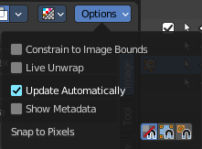
Constrain to Image Bounds
Forces the UV geometry to stay within the image bounds when editing.

Live Unwrap
Continuously unwrap the selected UV island while transforming pinned vertices.

Update Automatically
Update other editor windows simultaneously with the changes in the Image Editor.

UV local view
A mesh can have more than one material, and so more than one texture. Display only faces that are assigned to the currently displayed image.

Show Metadata
Draw Metadata properties of the image.

Snap to Pixels
Enables the pixel snapping with two methods. Corner or center.

